**LAB 7 (SOFTWARE)**

**ROLL_NO: 20k-0409**

**NAME: MUKAND KRISHNA**

**LAB TASK#1  
A)** Design and implement a 2-to-4-line decoder input E.

**Truth Table**

|  |  |  |  |
| --- | --- | --- | --- |
| Decimal Digit | Enable | Binary Inputs  A1 A0 | Outputs  D3 D2 D1 D0 |
| 0   1   2   3 | 1  0  0  0  0 | X X  0 0   0 1   1 0   1 1 | 1 1 1 1  **0** 1 1 1  1 **0** 1 1  1 1 **0** 1  1 1 1 **0** |

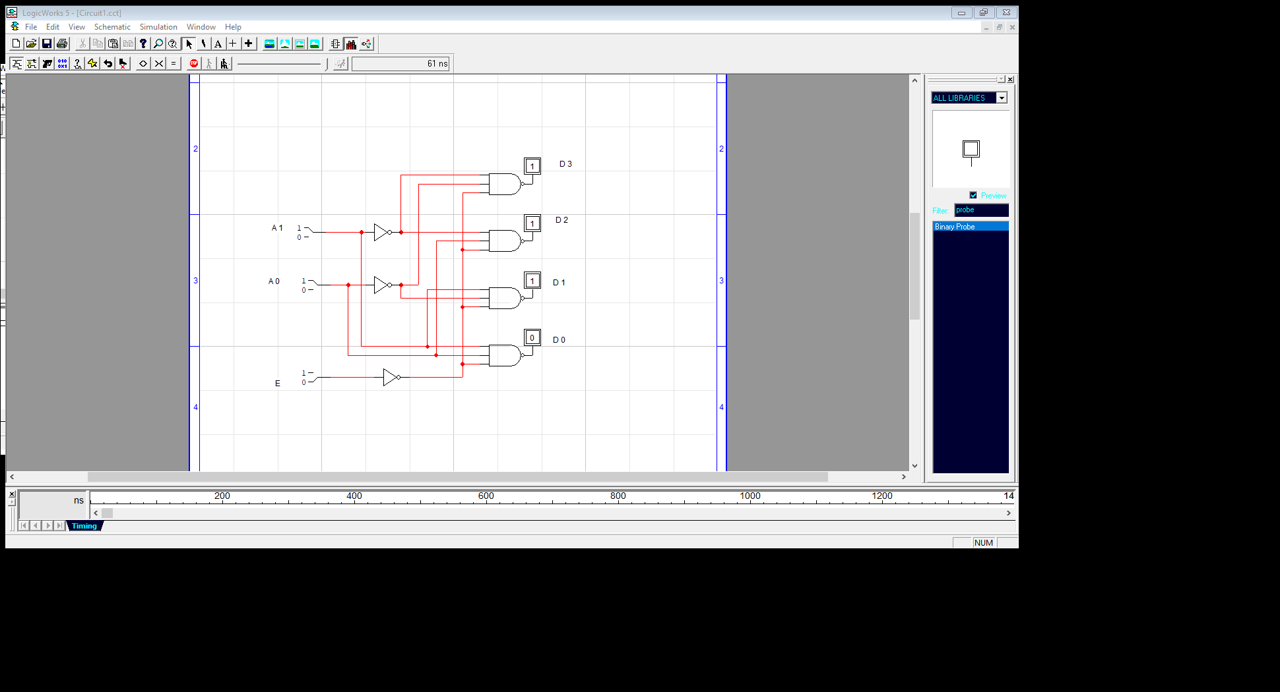

**B)** Find minimal SOP and POS expressions

|  |  |
| --- | --- |
|  |  |
|  |  |

***D0* A 0 A 0~ A 0 A 0~ *D1***

A1

A1~

|  |  |
| --- | --- |
|  |  |
| **1** |  |

A1

A1~

***D2* A0 A 0~ A 0 A 0~ *D3***

|  |  |
| --- | --- |
|  | **1** |
|  |  |

|  |  |
| --- | --- |
| **1** |  |
|  |  |

A1

A1~

|  |  |
| --- | --- |
|  |  |
|  |  |

A1

A1~

|  |  |
| --- | --- |
|  |  |
|  | **1** |

***SOP Expression***

|  |  |
| --- | --- |
|  |  |

D0=A’B’ D1=AB’

D2= A’B D3= AB

***POS Expression***

D0=A+B D1=A~+B

D2= A+B~ D3= A~+B~

**Lab Task #2**

3-8-line Decoder using IC 74LS138.

Inputs

Outputs

Enable

Select

|  |  |  |  |  |  |  |  |  |  |  |  |  |  |
| --- | --- | --- | --- | --- | --- | --- | --- | --- | --- | --- | --- | --- | --- |
| G1 | G2 A~ | G2 B~ | A2 | A1 | A0 | Y0~ | Y1~ | Y2~ | Y3~ | Y4~ | Y5~ | Y6~ | Y7~ |
| 1 | 0 | 0 | 0 | 0 | 0 | 0 | 0 | 0 | 0 | 0 | 0 | 0 | **1** |
| 1 | 0 | 0 | 0 | 0 | 1 | 0 | 0 | 0 | 0 | 0 | 0 | **1** | 0 |
| 1 | 0 | 0 | 0 | 1 | 0 | 0 | 0 | 0 | 0 | 0 | **1** | 0 | 0 |
| 1 | 0 | 0 | 0 | 1 | 1 | 0 | 0 | 0 | 0 | **1** | 0 | 0 | 0 |
| 1 | 0 | 0 | 1 | 0 | 0 | 0 | 0 | 0 | **1** | 0 | 0 | 0 | 0 |
| 1 | 0 | 0 | 1 | 0 | 1 | 0 | 0 | **1** | 0 | 0 | 0 | 0 | 0 |
| 1 | 0 | 0 | 1 | 1 | 0 | 0 | **1** | 0 | 0 | 0 | 0 | 0 | 0 |
| 1 | 0 | 0 | 1 | 1 | 1 | **1** | 0 | 0 | 0 | 0 | 0 | 0 | 0 |

**Circuit Diagram**

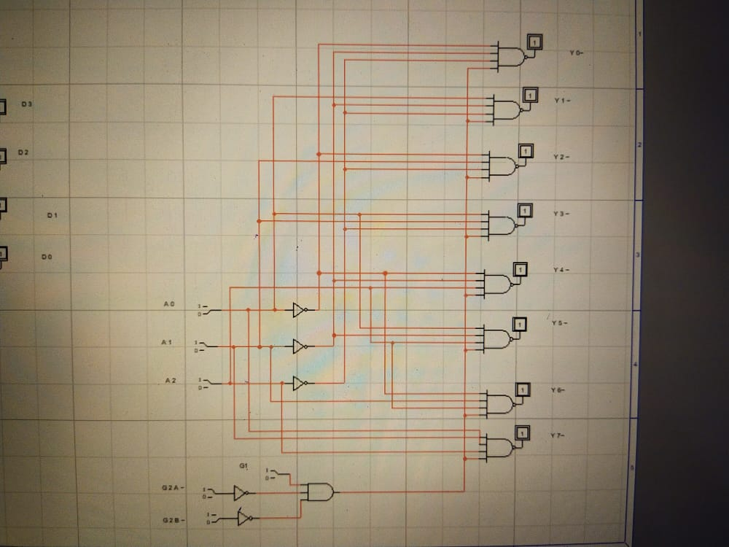

**Lab Task #3**BCD to Seven Segment Decoder using IC 74LS47

DIGITS

Outputs

Inputs

|  |  |  |  |  |  |  |  |  |  |  |  |  |  |  |
| --- | --- | --- | --- | --- | --- | --- | --- | --- | --- | --- | --- | --- | --- | --- |
| 1 | 1 | 1 | 0 | 0 | 0 | 0 | 0 | 0 | 0 | 0 | 0 | 0 | **1** | 0 |
| 1 | 1/0 | 1 | 0 | 0 | 0 | 1 | 1 | **0** | **0** | 1 | 1 | 1 | 1 | 1 |
| 1 | 1/0 | 1 | 0 | 0 | 1 | 0 | 0 | 0 | **1** | 0 | 0 | **1** | 0 | 2 |
| 1 | 1/0 | 1 | 0 | 0 | 1 | 1 | 0 | 0 | 0 | 0 | **1** | **1** | 0 | 3 |
| 1 | 1/0 | 1 | 0 | 1 | 0 | 0 | **1** | 0 | 0 | **1** | **1** | 0 | 0 | 4 |
| 1 | 1/0 | 1 | 0 | 1 | 0 | 1 | 0 | **1** | 0 | 0 | **1** | 0 | 0 | 5 |
| 1 | 1/0 | 1 | 0 | 1 | 1 | 0 | 0 | **1** | 0 | 0 | 0 | 0 | 0 | 6 |
| 1 | 1/0 | 1 | 0 | 1 | 1 | 1 | 0 | 0 | 0 | **1** | **1** | **1** | **1** | 7 |
| 1 | 1/0 | 1 | 1 | 0 | 0 | 0 | 0 | 0 | 0 | 0 | 0 | 0 | 0 | 8 |
| 1 | 1/0 | 1 | 1 | 0 | 0 | 0 | 0 | 0 | 0 | **1** | **1** | 0 | 0 | 9 |

**LT~** **RBI~ RBO~ A3 A2 A1 A0 a~ b~ c~ d~ e~ f~ g~**